

Hand Held Terminal M-8L:

APPLICATIONS  THAT  EMPOWER | 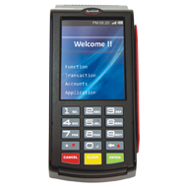

Overview:
G-8L a mobile handheld data capture terminal to process and transmit information to host computers in real time. The simple user friendly design allows you to operate with easy and light weight and handy. This can be integrated with external Bio-Metric finger print scanner to enhance flexibility in operations. Inbuilt thermal graphic printer enables you to print receipt for the transaction. This M-8L has high QVGA TFT LCD display and keypad with good user interface. Collected data can be uploaded to a PC via USB/RS-232 serial interface and GSM/GPRS wireless interface. Hence increases the velocity of business decisions.

32 bit Processor
Thermal Printer
GSM/LAN/USB
Micro SD Card

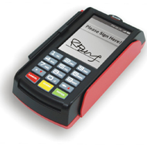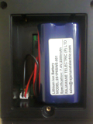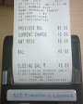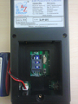

USB & RS232 Ports Battery Compartment Bill Printing SIM card Access
Features:  - 30 Keys Elastomeric designed keypad  - Compact and Comprehensive  - Large bright TFT display  - Self diagnostic features  - Fast-Intelligent-Versatile-Affordable  - RS-232 communication port  - USB Device(Host) | - Built-in RFID Transceiver  - Built-in 2 inch thermal printer  - Lithium-Ion rechargeable battery  - User programmable  - Easy paper loader  - Built-in GSM/GPRS Modem
Application Areas:  - Ticketing  - Retail outlet Billing & collection  - Utility Meter Reading & Billing  - Field Data Collection  - Order Booking  - Receipt Printing  - Parking | - Toll gate Billing & Collection  - Police e- Challan  - Tax Collection  - Inventory Management  - Market Survey  - Loyalty Applications  - Micro Finance  - Public Distribution System
Supporting Utilities: SDK with APIs

1 | Micro Processor | ARM Cortex-A8 with Mali400 MP2
 | CPU Speed | 1 GHz
 | System Memory | 512 MB Flash memory, 1GB DDR3,up to 32GB micro SD card
 | Operation System | Linux ,kernel v3.2
 | Display | 3.5” QVGA TFT LCD
 | Battery | Li-ion 7.4V, 2.2Ah
 | Keyboard | elastomeric type
 | Communication Module | - GSM/GPRS Interface  Optional:  Blue tooth , Wi-Fi  HF RFID Transceiver  IRDA  GSM/GPRS  GPS  Custom Keypad  Customized Software
 | Peripheral Ports | 1x RS-232; 2x USB (HOST &Client)
 | Printer | 2/3Inch Integrated Thermal Printer (72 mm width, speed 80mm/s,no of dots/line 576).
 | Operating Temperature | 0°C to 55°C
 | Humidity | 95% RH non condensing
 | Power Adaptor | AC input 90 - 305V, 50/60Hz DC output10V, 2.5A
 | Enclosure | Poly carbonate
 | Dimensions | 230 x 60 x 108 mm ( L x H x W)
 | Weight | 400 grms

System Concept and Architecture Diagram:

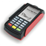
FIRE WALL
WEB SERVER
DATABASE
SERVER
Circle wise APPLICATION
SERVERS
HANDHELD
DEVICE
USER

GVM Electronic Systems.

Registered office:  502, Sri sai land mark, Block-A  Street No-8,Habsiguda  Hyderabad - 500007,  Telangana (INDIA).  Website : www.gvmgroup.co.in |  | R&D Center:  1-7-9/3, Level 1 Harihara Estates,  Opp ISI, Street No. 8,Habsiguda,  Hyderabad - 500007  Andhra Pradesh (INDIA)  Tel : 040 – 40073218.

